HSLA

📘 Definition
# Source: AI Source: Provided by: [Data Path: Persons Table -> ID Column: 1, Name_En Column: Motasem Essam] -> From: [ChatGPT] on [5/2/2026]
The HSLA color model is an extension of the HSL model that adds an extra component called Alpha (A) for transparency.
It represents colors using:
- H = Hue (type of color)
- S = Saturation (color intensity)
- L = Lightness (brightness level)
- A = Alpha (opacity / transparency)

🎨 How HSLA works
# Source: AI Source: Provided by: [Data Path: Persons Table -> ID Column: 1, Name_En Column: Motasem Essam] -> From: [ChatGPT] on [5/2/2026]
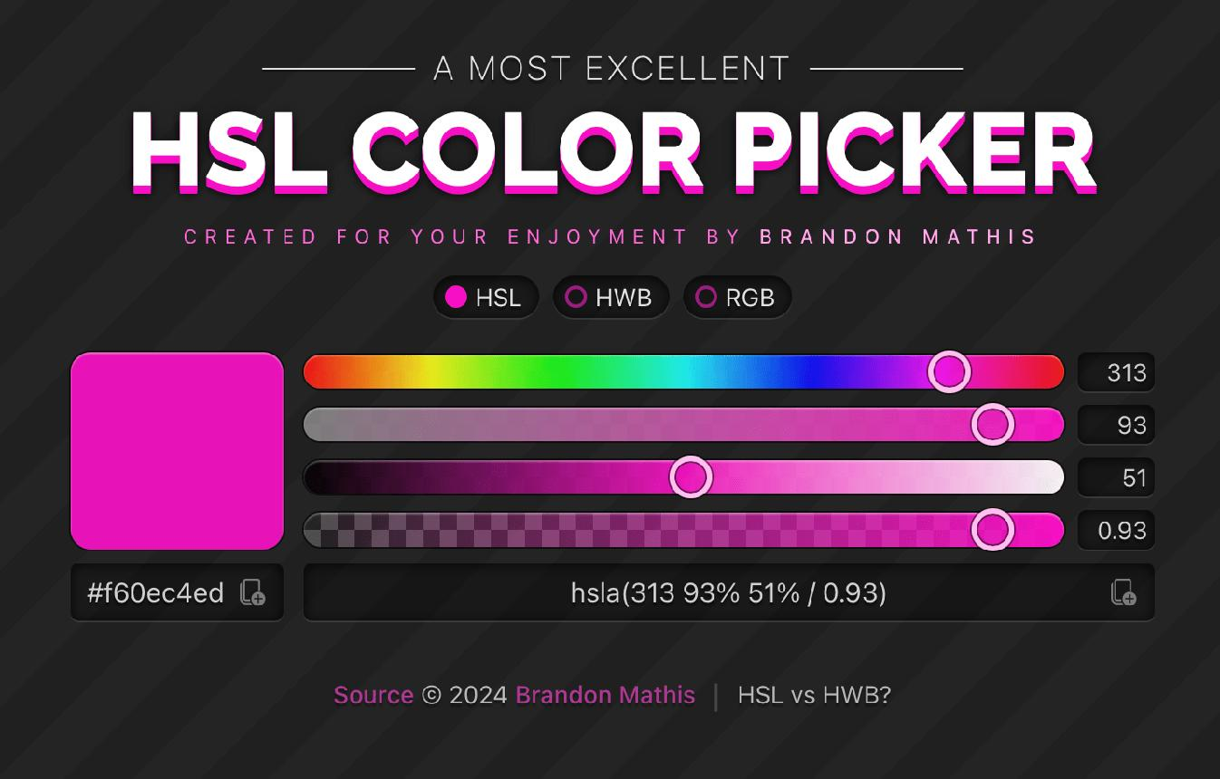
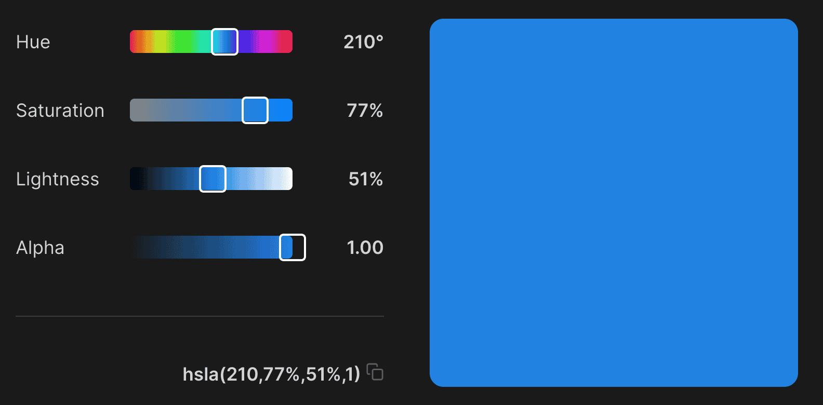
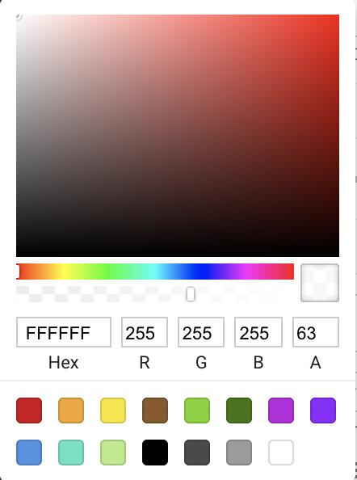
- Hue → selects the color (0°–360°)
- Saturation → controls how vivid the color is (0%–100%)
- Lightness → controls brightness
  - 0% = black
  - 50% = normal color
  - 100% = white
- Alpha → controls transparency
  - 0 = fully transparent
  - 1 = fully opaque

🧠 HSLA Examples
# Source: AI Source: Provided by: [Data Path: Persons Table -> ID Column: 1, Name_En Column: Motasem Essam] -> From: [ChatGPT] on [5/2/2026]
HSLA is written like this:
HSLA(H°, S%, L%, A)
🎯 Basic examples
- Red (solid) → HSLA(0°, 100%, 50%, 1)
- Green (semi-transparent) → HSLA(120°, 100%, 50%, 0.5)
- Blue (very transparent) → HSLA(240°, 100%, 50%, 0.2)
🎨 Mixed color examples
- Yellow (transparent) → HSLA(60°, 100%, 50%, 0.6)
- Pink (light red) → HSLA(0°, 100%, 80%, 1)
- Dark Purple (semi-transparent) → HSLA(270°, 100%, 25%, 0.7)

🧑‍💻 Where HSLA is used
# Source: AI Source: Provided by: [Data Path: Persons Table -> ID Column: 1, Name_En Column: Motasem Essam] -> From: [ChatGPT] on [5/2/2026]
- 🌐 Web design (CSS styling with transparency)
- 🎨 UI/UX design (overlays, backgrounds, effects)
- 📱 App interfaces (menus, popups, shadows)
- 🖌️ Graphic design tools

🚀 In short:
# Source: AI Source: Provided by: [Data Path: Persons Table -> ID Column: 1, Name_En Column: Motasem Essam] -> From: [ChatGPT] on [5/2/2026]
HSLA = HSL color model + transparency (Alpha), used to create colors with opacity effects.

